# WBEZ App Notifications

**WBEZ App System Settings**

* https://xd.adobe.com/view/e9f0eff8-15a9-439d-8fae-ebc42dca7324-bca3/screen/0292c104-6813-483e-912d-016f582edb1c

**New notification system flow**

* https://xd.adobe.com/view/13297538-15e1-423a-985a-c1dd717a5c35-467a/

**Notification permissions**

* When to ask permission
  + When the user knows the value of WBEZ notifications
  + The user opens the app for the first time
    - Once a user clicks ‘Don’t Allow’ at this stage, then it’s a done deal. The only other way of reversing this is with a [re-permissions campaign](https://blog.hurree.co/blog/how-to-re-engage-app-users-who-have-opted-out) using other channels such as email or in-app messaging.
    - Users who have just downloaded your app do not necessarily have a clear understanding of the value the app will bring to them
    - This offense is so frequent that users barely read the message anymore
    - In many of our studies, the immediate response is to click Don’t Allow.
    - the app Cluster took this approach and only about [30 - 40 % of users opted in](https://techcrunch.com/2014/04/04/the-right-way-to-ask-users-for-ios-permissions/).
    - This could be possible if using pre- permission before system dialog
  + Criteria requirements before launching permission: a certain number of sessions
    - if you set your permission request to launch after the user has opened the app 3 or more times then they have got some time to get to know the value of your app and are more inclined to opt-in.
    - Wait until users complete an action in-app
  + Ask after interacting with the audio player
    - Gives time for the app to demonstrate the value
    - Risk of users forgetting about the app after the download
    - Ties opt-in permission request to app value
* What?
  + A benefit explanation on the first open before system dialog or pre-permission
    - This could increase the likelihood of the user allowing notification permissions on the first launch
    - Ability to test pre-permission with different styles, wording, and layout in order to hit your best conversion rate
    - If your user says yes to your own message then you can go ahead and launch the iOS permission dialogue to get them to opt-in.
    - If they select don’t allow don’t launch the iOS dialogue and try again at a later date when you feel your user is more engaged.

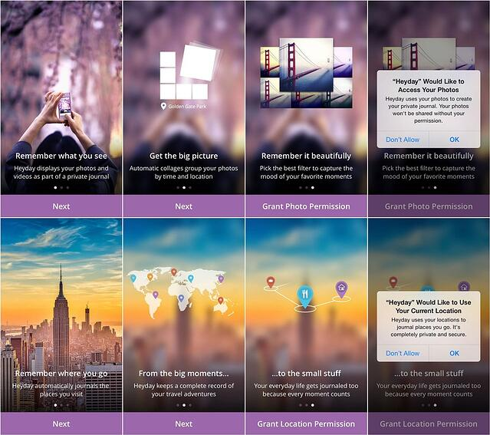

* + System pop up that tells users what information notifications will contain

**WBEZ App Notification Ideas**

Featured

Breaking news

Listen now breaking broadcast

Weekly featured

Show now live/new episode notifications

Onboarding notifications

* When
  + 24 hours after download with no open
* What?
  + Evergreen Mood
  + CTA to check out their new download

# Notification Notes

## Apple

* You can only ask for users to opt in to push messaging once
  + Users can change this by accessing system notification settings
* System Notification Settings
  + Expose infrequently changed configuration options in Settings.
* Notification types
  + App Clips - Provide users a shortcut to selected content and features of your app. communicate important information to users of your app, regardless of whether your app is running on the user’s device
  + User Notifications
  + Custom notifications
  + -Custom notifications, X is live in 15, 5, 20, or 1

| Interruption level | Overrides scheduled delivery | Breaks through Focus | Overrides Ring/Silent switch |
| --- | --- | --- | --- |
| Passive  Information people can view at their leisure, like a restaurant recommendation. | No | No | No |
| Active  Information people might appreciate knowing about when it arrives, like a score update on their favorite sports team. | No | No | No |
| Time Sensitive  Information that directly impacts the user and requires their immediate attention, like an account security issue or a package delivery. | Yes | Yes | No |
| Critical  Urgent information about personal health and public safety directly impacts the user and demands their immediate attention. Critical notifications are extremely rare and typically come from governmental and public agencies or healthcare apps. You must get an entitlement to use the Critical interruption level. | Yes | Yes | Yes |

## **Android**

* Android users are automatically opted into receiving push messages (a feature that can be shut off in the settings section).
* Importance
  + Users can change the importance of each channel on Android 8.0 and higher
  + Urgent: Makes a sound and appears as a heads-up notification.
  + High: Makes a sound.
  + Medium: No sound.
  + Low: No sound and does not appear in the status bar.
* Activity from notification
  + Special activity
    - The user only sees this activity if it's started from a notification. In a sense, this activity extends the notification UI by providing information that would be hard to display in the notification itself. So this activity does not need a back stack.
  + Regular activity
    - This is an activity that exists as a part of your app's normal UX flow. So when the user arrives in the activity from the notification, the new task should include a complete [back stack](https://developer.android.com/guide/components/activities/tasks-and-back-stack), allowing them to press Back and navigate up the app hierarchy.
* Anatomy
  + Title
  + Text
* Types
  + Toast Notification – Shows message that fades away after a few seconds. (Background type also)
  + Status Notification – Shows notification message and displayed till user action. (Background type also)
  + Dialog Notification – Comes out of an active Activity.

**UX Design Notes**

* Thoughtfully prioritize configuration options within your app.
* Your app’s main screen is a good place for options that are essential or that change frequently.
* Secondary screens are better for options that change only occasionally.- Apple Human Interface Guidelines
* 5 push-notification mistakes that mobile apps make frequently: https://www.nngroup.com/articles/push-notification/

**Notification No-No’s**

1. Asking users to enable notifications in the initial launch

* Users who have just downloaded your app do not necessarily have a clear understanding of the value the app will bring to them
* This offense is so frequent that users barely read the message anymore. In many of our studies, the immediate response is to click Don’t Allow.
* take advantage of the [reciprocity principle](https://www.nngroup.com/articles/reciprocity-principle/) and offer users some value first. Allow them to experience the app and only in a later session ask them to accept notifications.
  + The reciprocity principle is one of the basic laws of social psychology: It says that in many social situations we pay back what we received from others.

1. Neglecting to tell users what information notifications will contain
2. Sending burst notifications
3. Sharing irrelevant content

* “Don’t use notifications to send marketing or promotional content unless people explicitly agree to receive such information. When people want to learn about new features, content, or events related to your app, they can grant their permission to receive marketing notifications.”

1. Making it difficult to turn off notifications